Mini Project Report

Subject:- Mechatronics

Project name:- Automatic Staircase Light Circuit

**Introduction**:-

This **automatic staircase light circuit** switches on the staircase lights automatically when someone enters on the stairs and gets off after some time. There are two important components in this circuit, first is **PIR Sensor** (Passive Infrared Sensor) and second is [Relay](https://circuitdigest.com/article/relay-working-types-operation-applications).

**Construction:-**

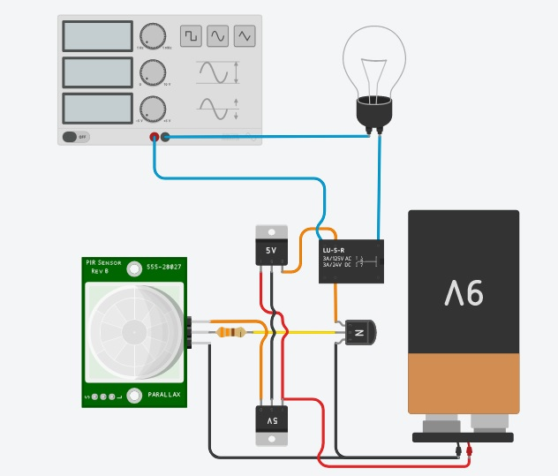

**Components of system:**

* PIR (Passive Infrared Sensor)
* IC (7805) – 2 nos.
* Resistor (330 ohm)
* NPN Transistor(BC547)
* Relay (5 volt)
* DC Battery (9 volt)
* Screw connector
* Bulb (10 Watt)
* Two pin

**Working of each Component:-**

1. PIR (Passive Infrared Sensor)

Passive Infrared Sensor (PIR) is very useful module, used to build many kinds of Security Alarm Systems and Motion Detectors. It is called passive because it receives infrared, not emits. Basically PIR sensor detects any change in heat, and whenever it detects any change, its output PIN becomes HIGH. They are also referred as Pyroelectric or IR motion sensors.

Here we should note that every object emits some amount of infrared when heated. Human also emits infrared because of body heat. PIR sensors can detect small amount of variation in infrared. Whenever an object passes through the sensor range, it produces infrared because of the friction between air and object, and get caught by PIR.

The main component of PIR sensor is Pyroelectric sensor shown in figure (rectangular crystal behind the plastic cap). Along with this, [BISS0001 ("Micro Power PIR Motion Detector IC"](http://www.ladyada.net/media/sensors/BISS0001.pdf)), some resistors, capacitors and other components used to build PIR sensor. BISS0001 IC take the input from sensor and does processing to make the output pin HIGH or LOW accordingly.

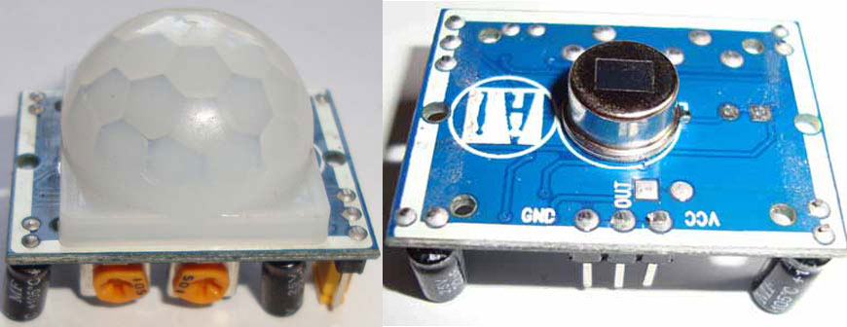

Pyroelectric sensor divide in two halves, when there is no motion, both halves remain in same state, means both senses the same level of infrared. As soon as somebody enters in first half, the infrared level of one half becomes greater than other, and this causes PIRs to react and makes the output pin high.

Pyroelectric sensor is covered by a plastic cap, which has array of many Fresnel Lens inside. These lenses are curved in such a manner so that sensor can cover a wide range.

PIRs takes some time to stable itself according to surrounding conditions, so you can find, LED turn ON and OFF randomly for about 10-60 seconds.

Now when we find the LED blinking whenever there is any motion, look back of the PIR, you will find a jumper which is placed between outer corner PIN and middle PIN (see diagram above). This is called “non-retriggering” Or “**Non-repeatable trigger”**and jumper said to be in L position. In this position LED will blink continuously until there is motion.

Now if you connect this jumper between inner corner PIN and middle PIN, then LED will stay on all the time till there is any motion. This one is called “retriggering” or “**Repeatable trigger”**and jumper said to be in H position.

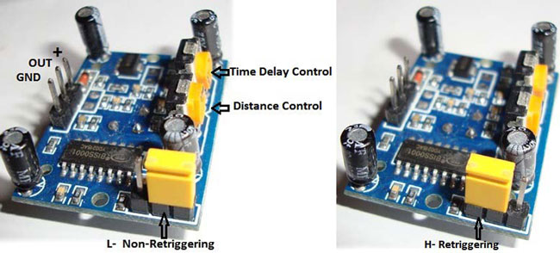

There are two potentiometers (shown in above figure), used to set the time delay and distance range. Time delay is the duration in which the LED will remain ON (out pin HIGH). In Non repeatable triggering, OUTPUT will become low automatically after the time delay. In Repeatable triggering OUTPUT will also become low after time delay, but if there is a continuous human activity; OUTPUT will remain HIGH even after the time delay.

Turn the **Distance Adjustment potentiometer** clockwise rotation, increased sensing distance (about 7 meters), on the other hand, the sensing distance decreases (about 3 meters).

Turn the Time delay potentiometer clockwise rotation sensor the delay lengthened (600S, 10 minutes), on the opposite side, shorten the delay (0.3 second).

Generally PIR detects infrared of 8 to 14 micrometre of wavelength and has range of 3-15 meters with a field of view less than 180 degrees. This range can vary upon different models. Some ceiling PIRs can cover 360 degrees. PIRs generally operate at 3-9V DC.

1. IC (7805)

Voltage sources in a circuit may have fluctuations resulting in not providing fixed voltage outputs. A voltage regulator IC maintains the output voltage at a constant value. 7805 IC, a member of 78xx series of fixed linear voltage regulators used to maintain such fluctuations, is a popular voltage regulator integrated circuit (IC). The xx in 78xx indicates the output voltage it provides. 7805 IC provides +5 volts regulated power supply with provisions to add a heat sink.

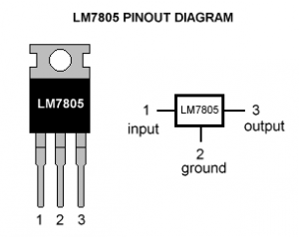

7805 IC Rating

* Input voltage range 7V- 35V
* Current rating Ic = 1A
* Output voltage range   VMax=5.2V ,VMin=4.8V

Pin Details of 7805 IC

|  |  |  |  |
| --- | --- | --- | --- |
| Pin No. | Pin | Function | Description |
| 1 | INPUT | Input voltage (7V-35V) | In this pin of the IC positive unregulated voltage is given in regulation. |
| 2 | GROUND | Ground (0V) | In this pin where the ground is given. This pin is neutral for equally the input and output. |
| 3 | OUTPUT | Regulated output; 5V (4.8V-5.2V) | The output of the regulated 5V volt is taken out at this pin of the IC regulator. |

1. Resistor:-

A resistor is a [passive](https://en.wikipedia.org/wiki/Passivity_(engineering)) [two-terminal](https://en.wikipedia.org/wiki/Terminal_(electronics)) [electrical component](https://en.wikipedia.org/wiki/Electronic_component) that implements [electrical resistance](https://en.wikipedia.org/wiki/Electrical_resistance) as a circuit element. In electronic circuits, resistors are used to reduce current flow, adjust signal levels, to divide voltages, [bias](https://en.wikipedia.org/wiki/Biasing) active elements, and terminate [transmission lines](https://en.wikipedia.org/wiki/Transmission_line), among other uses. High-power resistors that can dissipate many [watts](https://en.wikipedia.org/wiki/Watt) of electrical power as heat, may be used as part of motor controls, in power distribution systems, or as test loads for [generators](https://en.wikipedia.org/wiki/Electric_generator). Fixed resistors have resistances that only change slightly with temperature, time or operating voltage. Variable resistors can be used to adjust circuit elements (such as a volume control or a lamp dimmer), or as sensing devices for heat, light, humidity, force, or chemical activity.

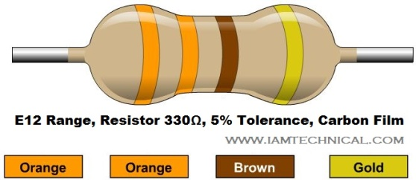

1. NPN transistor:-

In this circuit the npn transistor is act as a switch.

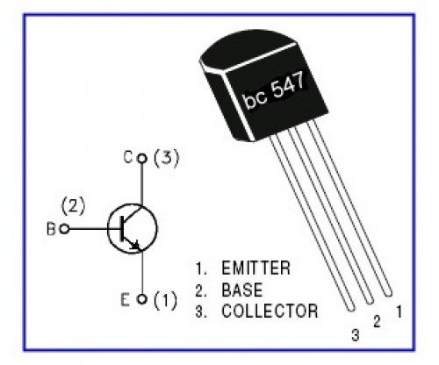

BC 547 (NPN transistor):

Specifications**:**

* BIPOLAR TRANSISTOR, NPN, 45V, TO-92
* Transistor Polarity: NPN
* Collector Emitter Voltage V(br)ceo: 45V
* Transition Frequency Typ ft: 300MHz
* Power Dissipation Pd: 625mW
* DC Collector Current: 100mA

1. Relay

[Relay](https://circuitdigest.com/article/relay-working-types-operation-applications) is an electromagnetic switch, which is controlled by small current, and used to switch ON and OFF relatively much larger current. Means by applying small current we can switch ON the relay which allow much larger current to flow. Relay is the good example of controlling the AC (alternate current) devices, using a much smaller DC current.  Commonly used Relay is **Single Pole Double Throw (SPDT)** Relay, it has five terminals as below:

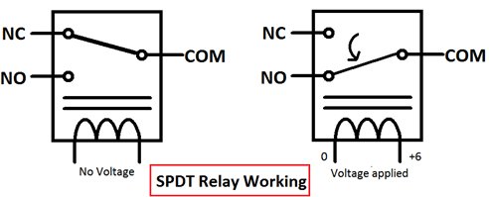

Working ofsystem**:**

* The PIR sensor sense the motion within its range, if sensor receives IR rays within its range, it create a signal.
* This high voltage signal sends to the base of npn transistor (BC547) via Resistor (330 ohm).
* As base obtained signal in the form of small electric current, it allows to flow the current from collector to emitter.
* When currents start flowing from collector to emitter, it activates to relay.
* As relay activates com line disengage with normally closed point & engage with normally open point.
* Due to activation of relay the bulb becomes ON.

**Conclusion:-**

From this mini project, we study & understand working of different electronic components. We study & learn the soldering process and PCB designing. from this project we study various types of sensor and there application.